

**Examination, 2017**

**Question/Answer Booklet**

ECONOMICS MOCK EXAMINATION

|  |  |  |  |  |  |  |  |  |  |
| --- | --- | --- | --- | --- | --- | --- | --- | --- | --- |
|  |  |  |  |  |  |  |  |  |  |

**Student Number: in figures**

**In words:**

|  |
| --- |
|  |
|  |

**Student Name: __________________________________________**

#### Time allowed for this paper

Reading time before commencing work: ten minutes

Working time for paper: three ( 3 ) hours

**Materials required/recommended for this paper**

***To be provided by the candidate***

Standard items: pens (blue/black preferred), pencils (including coloured), sharpener,

correction fluid/tape, eraser, ruler, highlighters

Special items: non-programmable calculators approved for use in the WACE examinations

**Important note to candidates**

No other items may be taken into the examination room. It is **your** responsibility to ensure that you do not have any unauthorised notes or other items of a non-personal nature in the examination room. If you have any unauthorised material with you, hand it to the supervisor **before** reading any further.

**Structure of this paper**

|  |  |  |  |  |  |
| --- | --- | --- | --- | --- | --- |
| **Section** | **Number of questions available** | **Number of questions to be answered** | **Suggested working time (minutes)** | **Marks available** | **Percentage of examination** |
| **Section One:**  **Multiple-choice** | **24** | **24** | **30** | **24** | **24** |
| **Section Two:**  **Data interpretation / Short response** | **3** | **3** | **70** | **36** | **36** |
| **Section Three:**  **Extended response** | **4** | **2** | **80** | **40** | **40** |
|  |  |  |  | **Total:** | **100** |

**Instructions to candidates**

1. Answer the questions according to the following instructions.

**Section One**: Answer all questions on the separate Multiple-choice Answer Sheet provided. For each question shade the box to indicate your answer. Use only a blue or black pen to shade the boxes. If you make a mistake, place a cross through that square, then shade your new answer. Do not erase or use correction fluid/tape. Marks will not be deducted for incorrect answers. No marks will be given if more than one answer is completed for any question.

**Section Two and Three**: Write answers your answers in this Question/Answer booklet.

2. You must be careful to confine your responses to the specific questions asked and to follow any instructions that are specific to a particular question.

3. Supplementary pages for the use of planning/continuing your answer to a question have been provided at the end of this Question/Answer booklet. If you use these pages to continue an answer, indicate at the original answer where the answer is continued, i.e. give the page number.

**Section One: Multiple Choice (24 Marks)**

This section has **24** questions. Answer **all** questions on the separate Multiple-choice Sheet.

For each question shade the box to indicate your answer. Use only a blue or black pen to shade the boxes. If you make a mistake, place a cross through that square, then shade your new answer. Do not erase or use correction fluid/tape. Marks will not be deducted for incorrect answers. No marks will be given if more than one answer is completed for any question.

Suggested working time: **30** minutes.

___________________________________________________________________

1. In 2016, Australia’s top two-way trading partners were:
2. China, Korea and the USA
3. China, Japan and Korea
4. China, USA and Japan
5. USA, Korea and the EU
6. Which of the following is likely to increase Australian exports?
7. an increase in income in Australia
8. a decrease in income in Australia
9. a decrease in income in foreign countries
10. an increase in income in foreign countries
11. Which of the following is most likely to improve Australia’s International Competitiveness?
12. Decreased government spending on infrastructure and education
13. A rise in Australia’s inflation rate relative to its trading partners
14. A depreciation of the US Dollar against the Australian dollar
15. Australia signing more free trade agreements with neighbouring countries
16. Restricting imports
17. can protect Australian jobs in the protected industry, which increases economic welfare of the country as a whole.
18. can protect Australian final goods and services in the protected industry and makes consumers better off.
19. can protect Australian final goods and services in the protected industry and increase economic welfare of the country as a whole.
20. can protect Australian jobs in the protected industry but will also lead to reductions in Australian output and income.
21. Which two of the following arguments are most likely to be used to justify protectionism?

i) To protect high cost domestic industries

ii) To protect strategically important industries

iii) To protect industries which are still immature

iv) To maximise government tax revenue

v) To protect environmental standards

1. ii. and iii.
2. i. and ii.
3. iv. and v.
4. iii. and iv.
5. 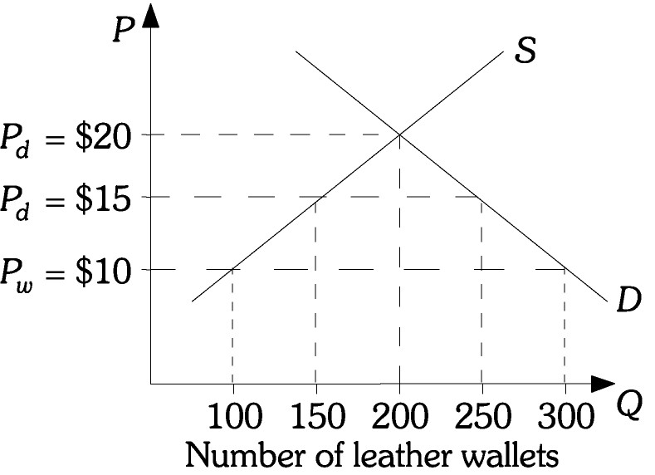Refer to the figure opposite. The domestic price of a leather wallet is $20. With free trade the price of a leather wallet is $10 and after a tariff is imposed the price is $15. After the tariff is imposed, tariff revenue will equal
6. $50.
7. $250.
8. $500.
9. $750.
10. If the Australian dollar appreciates then it is likely that the
11. Current account deficit will fall
12. Trade balance will fall
13. Inflow of foreign investment will rise
14. Net income balance will rise
15. This question is based on the graph below:

**Number of hours to**

**produce one Computer**

**AUSTRALIA**

**12**

**UK**

**6**

**Number of hours**

**to produce one Car**

**12**

**9**

According to the graph above which of the following is correct?

1. The UK has a comparative advantage in cars
2. Australia should export cars and import computers
3. The UK should produce both goods
4. Australia should import cars and export computers
5. Foreign Direct Investment impacts Australia by:
6. Increasing taxation revenue for the government
7. Creating increased interest payments overseas
8. Adding to Australia’s foreign debt levels
9. Adding to Australia’s foreign assets
10. A currency depreciation is more likely to increase a country's balance of trade if the demand for that country's exports is ________ and the demand for that country's imports is ________.
11. elastic; elastic
12. inelastic; elastic
13. elastic; inelastic
14. inelastic; inelastic
15. During 2016-17, Australia’s current account deficit fell to its lowest level in over 30 years. This was mainly due to
16. A large increase in the income balance.
17. A large increase in the trade balance.
18. A large fall in the terms of trade which increased exports.
19. A large inflow of foreign direct investment.
20. More German companies start to invest in Australia. This will lead to a(n)
21. decrease in the demand for dollars and an increase in the demand for euros.
22. increase in the demand for dollars and an increase in the supply of euros.
23. increase in the supply of dollars and a decrease in the demand for euros.
24. increase in the demand for dollars and a decrease in the supply of euros.
25. Which of the following is most likely to occur during an upswing phase of the business cycle?
26. Falling interest rates
27. Falling inflation
28. Falling structural unemployment
29. Falling levels of inventories
30. The relationship between real GDP and potential GDP over the business cycle can be best summarised by which of the following statements?
31. Real GDP fluctuates around potential GDP
32. Real GDP is always equal to potential GDP
33. Real GDP cannot be greater than potential GDP
34. Real GDP cannot be less than potential GDP
35. In a closed economy with no government, the national output increases by $300 billion as a result of an investment increase of $100 billion, than the MPC for this economy is:
36. 0.33
37. 0.67
38. 1
39. 3
40. A $100 million decrease in government expenditure on goods and services leads to an even larger decrease in aggregate demand because of
41. automatic fiscal stabilisers.
42. induced changes in consumption expenditures.
43. induced changes in aggregate supply.
44. induced changes in government taxes.
45. 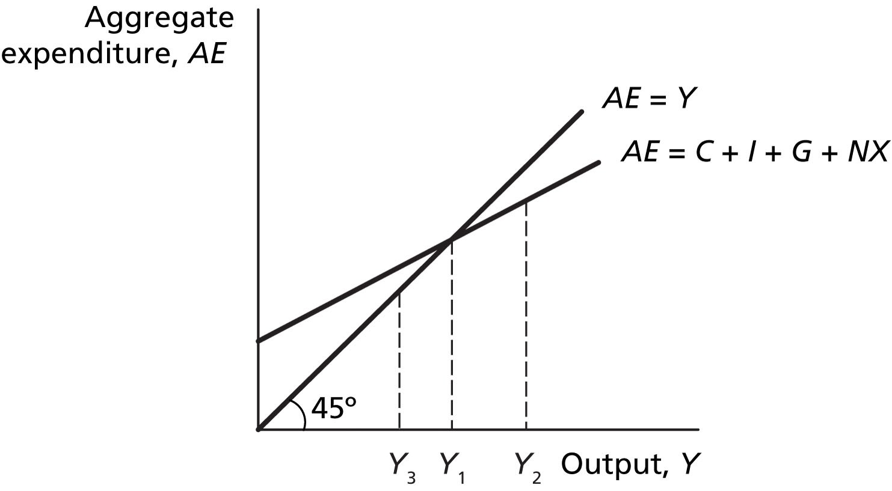 Refer to the Figure opposite. If the level of real GDP is initially Y3, spending is ________ production and there is an unintended ________ in inventories.
46. greater than; decrease
47. greater than; increase
48. less than; increase
49. less than; decrease
50. 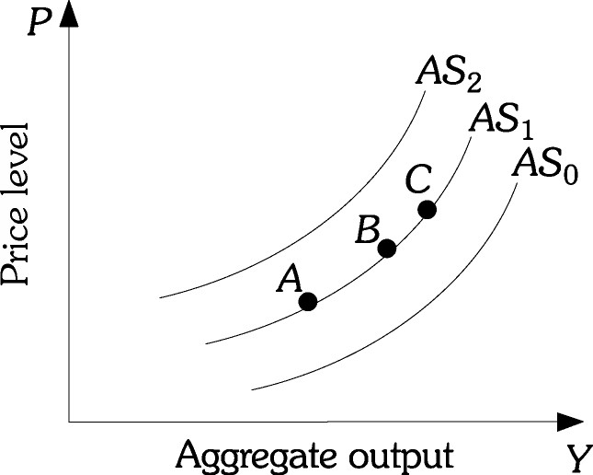 Refer to the Figure opposite. If a cyclone destroyed a large portion of the infrastructure along the east coast of Australia, this would cause the
51. economy to move from Point B to Point C along AS1.
52. economy to move from Point B to Point A along AS1.
53. aggregate supply curve to shift from AS1 to AS2.
54. aggregate supply curve to shift from AS1 to AS0.
55. Which one of the following is a weakness of using monetary policy to achieve the Australian Government’s macroeconomic goals?
56. Monetary policy requires political approval.
57. Indebted households are very sensitive to interest rate changes.
58. Banks are not legally required to pass on any changes in the cash rate.
59. Monetary policy is relatively inflexible in response to changing economic circumstances.
60. The ‘transmission mechanism’ refers to the way a change in interest rates affects economic activity. The transmission occurs via a number of channels. The channel that affects decisions by those in the economy with existing variable rate home loans is known as the
61. asset values channel.
62. exchange rate channel.
63. cost of credit channel.
64. cash flow channel.
65. A possible cause of a government’s actual budget surplus being smaller than its intended budget surplus could be:
66. A rise in the terms of trade
67. The RBA lowers interest rates over the period
68. A lower level of economic activity than forecast
69. Tax receipts have risen during the year
70. Australia’s unemployment rate decreased from 5.9% in January 2017 to 5.6% in June 2017. The impact of this change on government tax receipts, government outlays and the size of the budget deficit is likely to be that
71. tax receipts increase, outlays increase, the budget deficit is reduced.
72. tax receipts increase, outlays decrease, the budget deficit is reduced.
73. tax receipts increase, outlays decrease, the budget deficit is increased.
74. tax receipts decrease, outlays increase, the budget deficit is increased
75. Most economists agree that ___________ are the single most important source of productivity improvements.
76. increases in immigration
77. increases in physical capital
78. discoveries of natural resources
79. technological advances
80. Which of the following have contributed to structural change in the Australian economy?

i. changes in commodity prices

ii. aging of the population

iii. changes in inflation

iv. monetary policy

v. changes in technology

1. i, ii and iii
2. ii, iii and iv
3. i, ii and v
4. All five

__________________________________________________________________

***End of Section 1***

**THIS PAGE HAS BEEN**

**INTENTIONALLY LEFT BLANK**

**Section Two: Data interpretation/Short response (36 Marks)**

This section contains **three (3)** questions. Answer **all** questions. Write your answers in the spaces provided.

Spare pages are included at the end of this booklet. They can be used as additional space if required to continue an answer. If you need to use the space to continue an answer, indicate in the original answer space where the answer is continued, i.e. give the page number. Fill in the number of the question(s) that you are continuing to answer at the top of the page.

Suggested working time: **70** minutes.

__________________________________________________________________

**Question 25 (12 marks)**

Study the graph and answer the following questions.

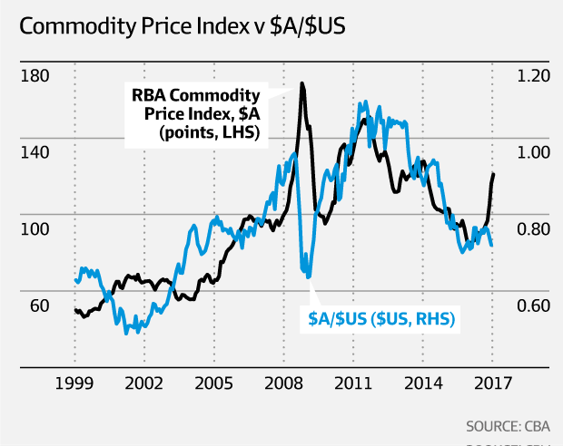

|  |  |  |
| --- | --- | --- |
| (a) | (i) What is measured by the commodity price index? | ( 1 mark ) |
|  |  | |
|  |  | |

|  |  |  |  |  |
| --- | --- | --- | --- | --- |
|  | (ii) Provide a reason for the change in the commodity price index between 2012-2015. | | ( 2 marks ) | |
|  |  | | | |
|  |  | | | |
|  |  | | | |
|  |  | | | |
| (b) | | Use the graph to explain the relationship between the commodity price index and the $A. ( 3 marks ) | |
|  | |  | |
|  | |  | |
|  | |  | |
|  | |  | |
|  | |  | |
|  | |  | |
|  | |  | |

|  |  |
| --- | --- |
| (c) | Explain why the $A did not rise given the spike in the commodity price index at the end of 2016. ( 2 marks ) |
|  |  |
|  |  |
|  |  |
|  |  |
|  |  |

|  |  |
| --- | --- |
| (d) | Describe the change in the value of the $A since 2011 and discuss three effects of this change on the economy. ( 4 marks ) |
|  |  |
|  |  |
|  |  |
|  |  |
|  |  |
|  |  |
|  |  |
|  |  |
|  |  |
|  |  |
|  |  |
|  |  |
|  |  |

**Question 26 (12 marks)**

Study the statistics which are for an economy similar to Australia’s and answer the questions which follow.

|  |  |  |  |  |  |
| --- | --- | --- | --- | --- | --- |
| Year | CPI | Change in GDP (%) | CAD (m) | Unemployment rate ($) | Participation rate (%) |
| 1 | 102 | 2 | -8 | 5.8 | 64 |
| 2 | 105 | 3 | -13 | 6.2 | 65 |
| 3 | 107 | 2 | -14 | 5.9 | 65 |
| 4 | 108 | 2 | -3 | 6.0 | 64 |

|  |  |  |
| --- | --- | --- |
| (a) | (i) Calculate the inflation rate in year 3. | ( 1 mark ) |
|  |  | |
|  |  | |

|  |  |  |
| --- | --- | --- |
|  | (ii) What is the growth rate in year 2? | ( 1 mark ) |
|  |  | |
|  |  | |

|  |  |  |  |
| --- | --- | --- | --- |
| (b) | Use data from the table to show the position of this economy on the business cycle. | | ( 4 marks ) |
|  | |  | |
|  | |  | |
|  | |  | |
|  | |  | |
|  | |  | |
|  | |  | |
|  | |  | |
|  | |  | |

|  |  |  |
| --- | --- | --- |
| (c) | What policy action should be undertaken in year 4 and what would the impact of such action be on the economy? | ( 6 marks ) |
|  |  | |
|  |  | |
|  |  | |
|  |  | |
|  |  | |
|  |  | |
|  |  | |
|  |  | |
|  |  | |
|  |  | |
|  |  | |
|  |  | |
|  |  | |
|  |  | |
|  |  | |

**Question 27 (12 marks)**

Use the article below to answer the questions that follow:

Penalty rate cuts could backfire on business

**Analysis**

By business reporter: [Michael Janda](http://www.abc.net.au/news/michael-janda/166854)

Thu 23 Feb 2017, 12:14pm

Let's start by calling a spade a spade. Sunday penalty rates have been cut by the Fair Work Commission. Not "equalised" or "brought in line" with Saturday rates. Cut.

Business, big and small, has been seeking this cut for years, saying Sunday penalties are a legacy of a bygone era where families went to church — one that's costing them a tidy sum.

They also argue it's a legacy that's been costing jobs, with many employers choosing not to open on Sundays, or to maintain just a skeleton staff (although ask yourself, just how many retailers, restaurants, cafes and bars are actually shut on Sunday?).

But the cuts to Sunday penalty rates could become a textbook example of unintended consequences, where a move supposed to increase employment instead hurts the economy and increases business failures and job losses.

Why? Because the hundreds of thousands of retail and hospitality workers affected by this decision are also customers.

|  |  |  |
| --- | --- | --- |
| (a) | Define unintended consequences | ( 1 mark ) |
|  |  | |
|  |  | |

|  |  |  |  |
| --- | --- | --- | --- |
| (b) | What economic reasons do employers give for the need to cut penalty rate on Sundays? | | ( 2 marks ) |
|  |  |  | |
|  |  |  | |
|  |  |  | |
|  |  |  | |
|  |  |  | |
|  |  |  | |

|  |  |  |
| --- | --- | --- |
| (c) | Use AS/AD analysis to explain the economic basis for the cuts. | ( 3 marks ) |
|  |  | |
|  |  | |
|  |  | |
|  |  | |
|  |  | |
|  |  | |
|  |  | |
|  |  | |
|  |  | |
|  |  | |

|  |  |  |
| --- | --- | --- |
| (d) | Use the aggregate expenditure model to describe the possible impacts on the economy. | ( 6 marks ) |
|  |  | |
|  |  | |
|  |  | |
|  |  | |
|  |  | |
|  |  | |
|  |  | |
|  |  | |
|  |  | |
|  |  | |
|  |  | |
|  |  | |
|  |  | |
|  |  | |
|  |  | |
|  |  | |
|  |  | |
|  |  | |

***End of Section 2***

**Section Three: Extended response (40 Marks)**

This section contains **four (4)** questions. Answer **two (2)** question.

Pages are included at the end of this booklet for planning and writing your answer.

* Planning: If you use the spare pages for planning, indicate this clearly at the top of the page.
* Answering the question: In the pages provided indicate clearly the number of the question you are answering.

Suggested working time: 80 minutes.

**___________________________________________________________________**

**Question 28**

|  |  |
| --- | --- |
| (a) | Describe factors that could improve Australia’s international competitiveness. |
|  | ( 10 marks ) |

|  |  |
| --- | --- |
| (b) | Analyse the impact of a fall in the exchange rate on different sectors of the Australian economy. ( 10 marks ) |
|  |  |

**Question 29**

|  |  |
| --- | --- |
| (a) | Explain why international trade and direct foreign investment are important to the Australian economy. ( 10 marks ) |

|  |  |
| --- | --- |
| (b) | Discuss the effect an increase in protectionism worldwide would have on the Australian economy. ( 10 marks ) |

**Question 30**

There has been a lot of speculation about the possibility of the RBA raising the cash rate in the last few years.

|  |  |
| --- | --- |
| (a) | What economic conditions would need to exist for the RBA to increase the cash rate and explain what impact this change would have on the Australian economy. ( 10 marks ) |

|  |  |
| --- | --- |
| (b) | Using contemporary examples, describe the strengths and weaknesses of Monetary Policy. ( 10 marks ) |
|  |  |

**Question 31**

|  |  |
| --- | --- |
| (a) | Explain the extent to which Australia’s recent fiscal policy measures are enabling the achievement of Australia’s economic objectives. ( 20 marks ) |

___________________________________________________________________

**End of Questions**

|  |
| --- |
|  |
|  |
|  |
|  |
|  |
|  |
|  |
|  |
|  |
|  |
|  |
|  |
|  |
|  |
|  |
|  |
|  |
|  |
|  |
|  |
|  |
|  |
|  |
|  |
|  |
|  |
|  |
|  |
|  |
|  |
|  |
|  |

|  |
| --- |
|  |
|  |
|  |
|  |
|  |
|  |
|  |
|  |
|  |
|  |
|  |
|  |
|  |
|  |
|  |
|  |
|  |
|  |
|  |
|  |
|  |
|  |
|  |
|  |
|  |
|  |
|  |
|  |
|  |
|  |
|  |
|  |
|  |
|  |
|  |
|  |
|  |
|  |
|  |
|  |
|  |
|  |
|  |
|  |
|  |
|  |
|  |
|  |
|  |
|  |
|  |
|  |
|  |
|  |
|  |
|  |
|  |
|  |
|  |
|  |
|  |
|  |
|  |
|  |
|  |
|  |
|  |
|  |
|  |
|  |
|  |
|  |
|  |
|  |
|  |
|  |
|  |
|  |
|  |
|  |
|  |
|  |
|  |
|  |
|  |
|  |
|  |
|  |
|  |
|  |
|  |
|  |
|  |
|  |
|  |
|  |
|  |
|  |
|  |
|  |
|  |
|  |
|  |
|  |
|  |
|  |
|  |
|  |
|  |
|  |
|  |
|  |
|  |
|  |
|  |
|  |
|  |
|  |
|  |
|  |
|  |
|  |
|  |
|  |
|  |
|  |
|  |
|  |
|  |
|  |
|  |
|  |
|  |
|  |
|  |
|  |
|  |
|  |
|  |
|  |
|  |
|  |
|  |
|  |
|  |
|  |
|  |
|  |
|  |
|  |
|  |
|  |
|  |
|  |
|  |
|  |
|  |
|  |
|  |
|  |
|  |
|  |
|  |
|  |
|  |
|  |
|  |
|  |
|  |
|  |
|  |
|  |
|  |
|  |
|  |
|  |
|  |
|  |
|  |
|  |
|  |
|  |
|  |
|  |
|  |
|  |
|  |
|  |
|  |
|  |
|  |
|  |
|  |
|  |
|  |
|  |
|  |
|  |
|  |
|  |
|  |
|  |
|  |
|  |
|  |
|  |
|  |
|  |
|  |
|  |
|  |
|  |
|  |
|  |
|  |
|  |
|  |
|  |
|  |
|  |
|  |
|  |
|  |
|  |
|  |
|  |
|  |
|  |
|  |
|  |
|  |
|  |
|  |
|  |
|  |
|  |
|  |
|  |
|  |
|  |
|  |
|  |
|  |
|  |
|  |
|  |
|  |
|  |
|  |
|  |
|  |
|  |
|  |
|  |
|  |
|  |
|  |
|  |
|  |
|  |
|  |
|  |
|  |
|  |
|  |
|  |
|  |
|  |
|  |
|  |
|  |
|  |
|  |
|  |
|  |
|  |
|  |
|  |
|  |
|  |
|  |
|  |
|  |
|  |
|  |
|  |
|  |
|  |
|  |
|  |
|  |
|  |
|  |
|  |
|  |
|  |
|  |
|  |
|  |
|  |
|  |
|  |
|  |
|  |
|  |
|  |
|  |
|  |
|  |
|  |
|  |
|  |
|  |
|  |
|  |
|  |
|  |
|  |
|  |
|  |
|  |
|  |
|  |
|  |
|  |
|  |
|  |
|  |
|  |
|  |
|  |
|  |
|  |
|  |
|  |
|  |
|  |
|  |
|  |
|  |
|  |
|  |
|  |
|  |
|  |
|  |
|  |
|  |
|  |
|  |

**End of Exam**